MasterClass Project

1. We need to setup webserver on vm instance
2. Install mysql client
3. Test the connectivity
4. Create sample php project
5. Connect to db
6. Update table

Step 1: Install web server package

sudo apt update

sudo apt install apache2 php php-mysql -y

sudo systemctl start apache2

sudo systemctl enable apache2

step 2: Install mysql client

Download the package:

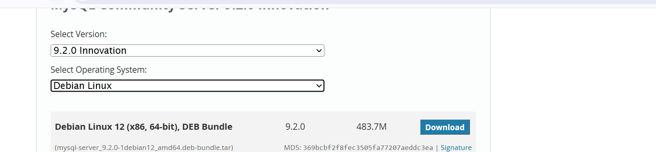

**Copy the link**

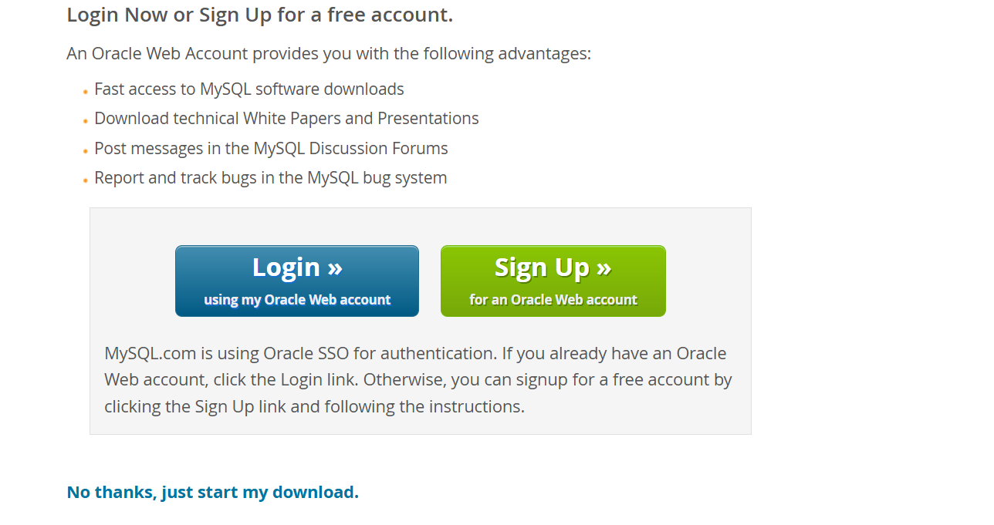

**mkdir mysql**

**cd mysql**

**wget** [**https://dev.mysql.com/get/Downloads/MySQL-9.2/mysql-server_9.2.0-1debian12_amd64.deb-bundle.tar**](https://dev.mysql.com/get/Downloads/MySQL-9.2/mysql-server_9.2.0-1debian12_amd64.deb-bundle.tar)

tar xvf mysql-server_9.2.0-1debian12_amd64.deb-bundle.tar

Install package in this order

dpkg -i mysql-community-client-plugins_9.2.0-1debian12_amd64.deb

dpkg -i mysql-community-client-core_9.2.0-1debian12_amd64.deb

dpkg -i mysql-common_9.2.0-1debian12_amd64.deb

dpkg -i mysql-community-client_9.2.0-1debian12_amd64.deb

dpkg -i mysql-client_9.2.0-1debian12_amd64.deb

Note down your SQL instance private ip

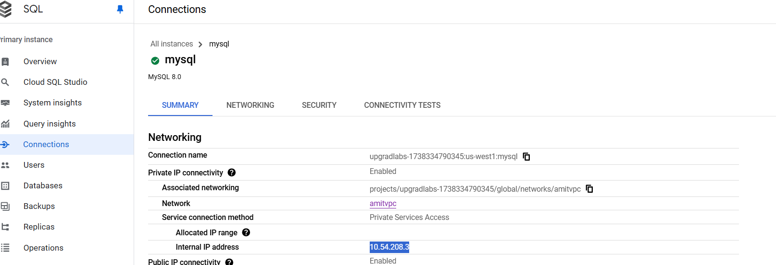

Run from the host

**Please provide your sql instance private ip, highlighted in red**

mysql --ssl-mode=DISABLED --host= database-1.czs4msomuf88.ap-south-1.rds.amazonaws.com --user=admin --password

Create DB, create table and insert

CREATE DATABASE mydb;

USE mydb;

SHOW TABLES;

DESCRIBE users;

CREATE TABLE users (

id INT AUTO_INCREMENT PRIMARY KEY,

name VARCHAR(100) NOT NULL,

email VARCHAR(100) NOT NULL UNIQUE

);

INSERT INTO users (name, email) VALUES ('John Doe', 'john@example.com');

Exit from mysql prompt : Type “exit”

Step 3: Add php code

Go to /var/www/html directory

cd /var/www/html

nano db_connect.php, modify the below code highlighted in red and add

<?php

$servername = "10.123.112.3"; // Change this to your MySQL server's private IP or hostname

$username = "root";

$password = "Welcome1";

$database = "mydb"; // Database name

// Create connection

$conn = new mysqli($servername, $username, $password, $database);

// Check connection

if ($conn->connect_error) {

die("Connection failed: " . $conn->connect_error);

}

echo "Connected successfully to MySQL!";

// Create Database

$sql = "CREATE DATABASE IF NOT EXISTS mydb";

if ($conn->query($sql) === TRUE) {

echo "Database created successfully";

} else {

echo "Error creating database: " . $conn->error;

}

?>

Add your db instance ip, password and db name: Example screenshot

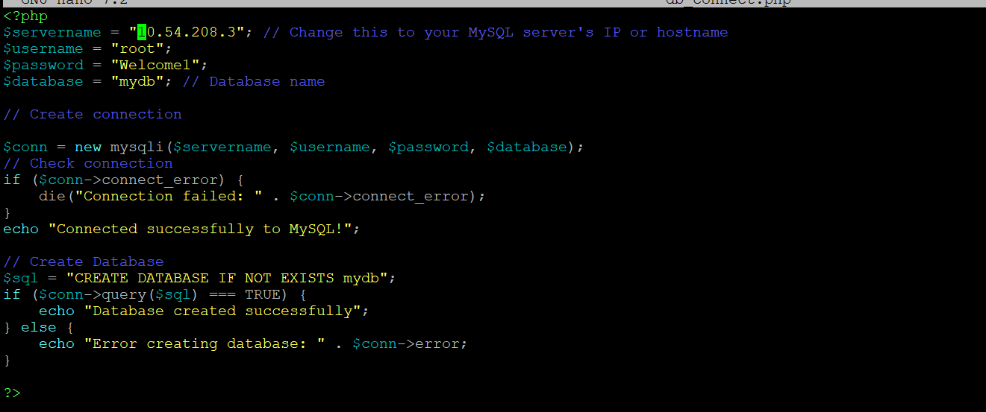

Restart apache2

systemctl restart apache2

Open using external(public) ip of cloud vm (Webserver)

<http://34.105.42.167/db_connect.php>

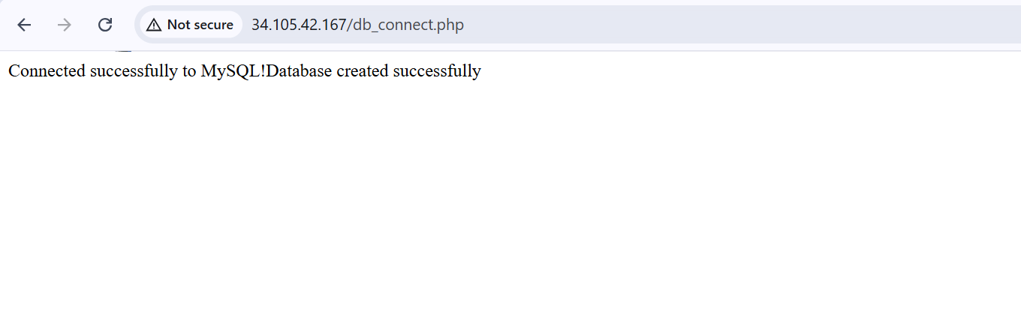

Add few more file to enhance the code, in /var/www/html location

File name: index.php and add below code

<?php

include 'db_connect.php';

// Ensure the connection is still open

if (!isset($conn) || $conn->connect_error) {

die("Database connection failed.");

}

// Fetch users from the database

$result = $conn->query("SELECT * FROM users");

if (!$result) {

die("Query failed: " . $conn->error);

}

?>

<!DOCTYPE html>

<html>

<head>

<title>Users List</title>

</head>

<body>

<h2>Users</h2>

<table border="1">

<tr><th>ID</th><th>Name</th><th>Email</th><th>Actions</th></tr>

<?php while ($row = $result->fetch_assoc()): ?>

<tr>

<td><?= htmlspecialchars($row['id']) ?></td>

<td><?= htmlspecialchars($row['name']) ?></td>

<td><?= htmlspecialchars($row['email']) ?></td>

<td>

<a href="edit.php?id=<?= $row['id'] ?>">Edit</a> |

<a href="delete.php?id=<?= $row['id'] ?>" onclick="return confirm('Are you sure?')">Delete</a>

</td>

</tr>

<?php endwhile; ?>

</table>

<a href="add.php">Add User</a>

</body>

</html>

<?php

// Close connection

$conn->close();

?>

File name: add.php

<?php

include 'db_connect.php';

if ($_SERVER["REQUEST_METHOD"] == "POST") {

$name = $_POST['name'];

$email = $_POST['email'];

$stmt = $conn->prepare("INSERT INTO users (name, email) VALUES (?, ?)");

$stmt->bind_param("ss", $name, $email);

if ($stmt->execute()) {

header("Location: index.php");

} else {

echo "Error: " . $stmt->error;

}

}

?>

<!DOCTYPE html>

<html>

<head>

<title>Add User</title>

</head>

<body>

<h2>Add User</h2>

<form method="POST">

Name: <input type="text" name="name" required><br>

Email: <input type="email" name="email" required><br>

<button type="submit">Add</button>

</form>

<a href="index.php">Back</a>

</body>

</html>

File name: delete.php

<?php

include 'db_connect.php';

$id = $_GET['id'];

$stmt = $conn->prepare("DELETE FROM users WHERE id=?");

$stmt->bind_param("i", $id);

if ($stmt->execute()) {

header("Location: index.php");

} else {

echo "Error: " . $stmt->error;

}

?>

File name: edit.php

<?php

include 'db_connect.php';

$id = $_GET['id'];

if ($_SERVER["REQUEST_METHOD"] == "POST") {

$name = $_POST['name'];

$email = $_POST['email'];

$stmt = $conn->prepare("UPDATE users SET name=?, email=? WHERE id=?");

$stmt->bind_param("ssi", $name, $email, $id);

if ($stmt->execute()) {

header("Location: index.php");

} else {

echo "Error: " . $stmt->error;

}

}

$result = $conn->query("SELECT * FROM users WHERE id=$id");

$user = $result->fetch_assoc();

?>

<!DOCTYPE html>

<html>

<head>

<title>Edit User</title>

</head>

<body>

<h2>Edit User</h2>

<form method="POST">

Name: <input type="text" name="name" value="<?= $user['name'] ?>" required><br>

Email: <input type="email" name="email" value="<?= $user['email'] ?>" required><br>

<button type="submit">Update</button>

</form>

<a href="index.php">Back</a>

</body>

</html>

Restart the service

systemctl restart apache2

Connect to external ip of cloud vm instance

<http://34.105.42.167/index.php>

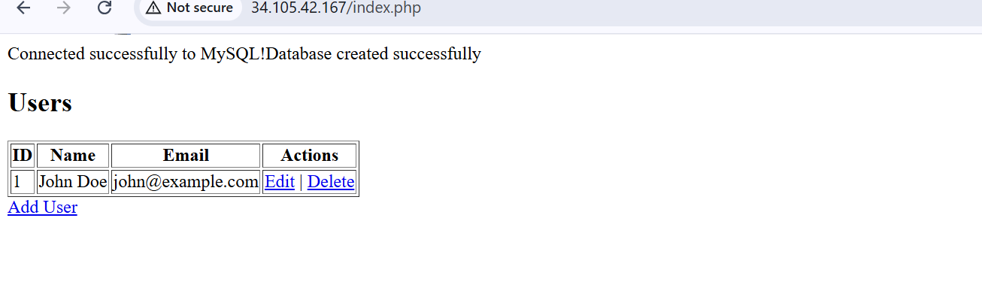

Take the backup

